
Fly High in Europe - Lesson Plan


Category: Computing
Year Group / Age Phase : Year 6 (Age 10 and 11 Years)

Learning Objective:
Create a kite game.

National Curriculum Objectives:

Design, write and debug programs tha accomplish specifi goals, including controlling or simulating physical systems; solve problems by decomposing them into smaller parts.

Use sequence, selection and repetition in programs; work with variables and various forms of input and output.

Resources:
Scratch

Differentiation:

All – Using a simple sequence create a moving sprite

Most – Using complex repeated sequences, create two sprites that move independently to each other.

Some – Using variables incorporate obstacles to make the game more interesting.

Introduction:

Show children a completed game which consists of two moving kite shaped sprites along with obstacles that reset the sprite if touched. What type of a game is this? What happens within the game?

Discuss with children what would be needed to program a game such as this. What type of sequences could we use? What is a variable? What variables could we add? How could we make our program smaller?

Talk partners – discuss what functions could be used in the Scratch to write this program. Then share with class

List functions – Control, Forever, If etc. Create working whiteboard. Recap what each function includes and display on whiteboard.

Main Lesson

Recap with children
- how to add/design a sprite.
- where to find each function
- how to add a variable

Children to work in pairs. Each pair is to design a kite game that should contain:
- two kite sprites that move independently using different keys on the computer keyboard.
- Obstacles such as clouds etc. that when hit reset the sprite to the start
- variables that can keep the score of each of the sprites

Explain the game must be engaging and fun.

Plenary

Pairs to evaluate other pair’s game. They should suggest two good things about the game along with on suggestion of improvement.

Select two or three games to display on the interactive whiteboard. Pairs then talk the class through their game explaining W.W.W. along with any debugging they had to perform.

All pairs to complete a self-evaluation form explaining what went well and wht they could improve within their game matching this to the success criteria.

For future lessons discuss what other types of game could the children make along with other programs they may use instead of Scratch.

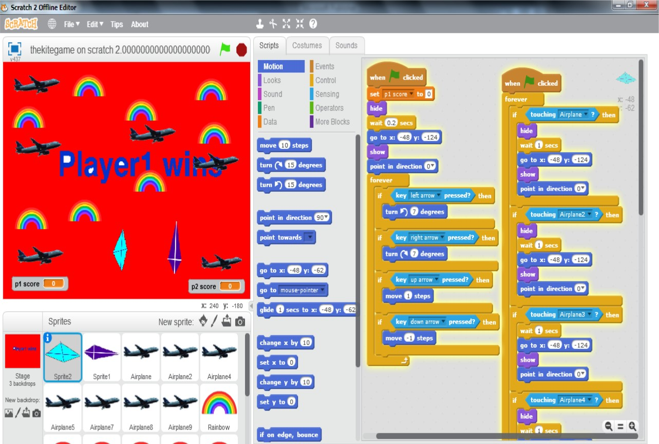
Photographs



