
Fly High in Europe - Lesson Plan
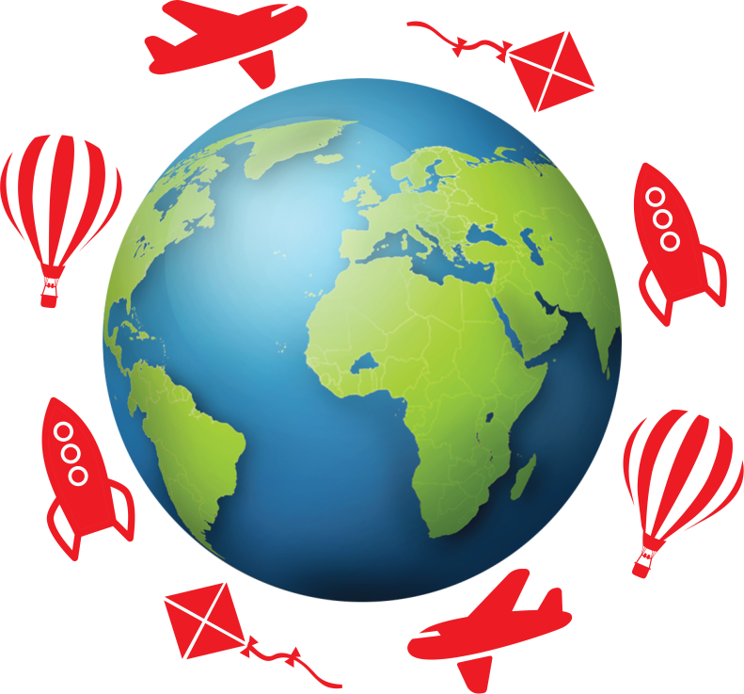

Category: Airport
National Curriculum Subject : DT
Year Group / Age Phase : 5 (9 - 10 years old)

Learning Objective:
Deisgn and Technology:
- Design with the user in mind, motivated by the service a product will offer.
- Make product through stages.
- Create and refine recipes, including ingredients and methods.

Resources:
Access to Ipads or computer suite
List of healthy foods

Differentiation:
Children give support resources to identify healthy options in food catagories.
All – Create a menu filled with healthy food options.

Most – show more detail within the refining of the recipes and the foods chosen.

Some – Can explain the different courses ad why they have been used.

Introduction:
Discuss the importance of healthy eating. Recap major food groups and how we can select from each to create a helathy meal.

Main Lesson
Children begin by discussing the types of food they eat when flying on an aeroplane. We then discuss the struggle to eat healthy during these times.
Can we create our own menu, to allow people to eat healthy and tasty food on a flight?
The children are given three catagories, starter, main course and dessert. The children use the food resources provided to select healthy options. They use ipads to research different combinations of these healthy foods to create their own meal.
Also using the ipads, children decument ingredients and methods to make these foods.
Next the children create their own colourful menu to promote the meals they have designed.
Plenary
Mini plenaries throughout, further discussing what are healthy options.
Plenary – children present their menu to the class, self evaluation of work, explaining what they think is good and how they could improve the menu.

Photographs


